**Experiment No: 01**

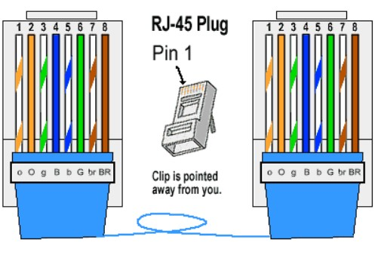**OBJECTIVE:** Steps for creating LAN cable Straight Cable

**APPARATUS:** LAN cable cat6, RJ45 connectors, crimping tool, ethernet cable tester

**THEORY:** STRAIGHT CABLES - The purpose of a Straight Ethernet cable is to directly connect one computer to another computer (or device) without going through a router, switch or hub.

**STEP 1: Strip your cable.** Use your cable strippers at about 1-2 inches from the end of the cable to remove the outer jacket.

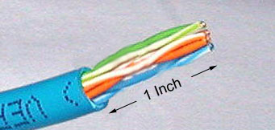

**STEP 2: Untwist the twisted pair wires all the way back to the jacket.** This can be done just like a regular twist-tie on a loaf of bread, but with four of them of different colors.

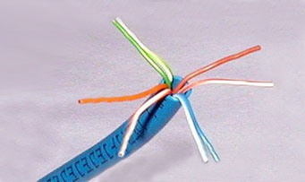

**STEP 3: Align the untwisted wires in the order necessary for your needs.** For this scenario, you'll be making a straight-through cable, which has both ends of the cable with the same alignment of wires, so it's easy enough to do. Since this is your first cable, we'll consult the cheat sheet to know what order we're aligning in!

**STEP 4: Cut the extra wire.** Once you've untwisted the wires, you'll have a superfluous amount of copper wiring left; we don't need this much, but it's good to have it in the previous step to help in aligning the colors properly. Use the wire-cutting scissors to cut these off.

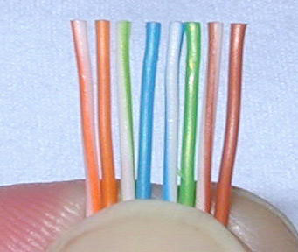

**STEP 5: Push the remaining wires into the RJ45 head.** Be careful not to bend the wires while pushing them in or you run the risk of creating a bad cable. You also don't want too little or too much wire left in the head; there's no definite length necessary, but it's pretty obvious to tell if there's too much cable or not enough. A short length of the jacket should be up the RJ45 head; use this knowledge as a reference.

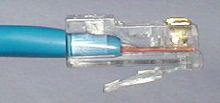

**STEP 6: Double-check that the wires are all the way up into the gold pins of the head and made it up in the proper order.** (Consult your cheat sheet if needed!)

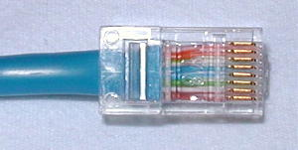

**STEP 7: Push the head into the open space of the crimping tool and squeeze it closed, hard.** If you don't crimp the cable all the way, the head may come off.

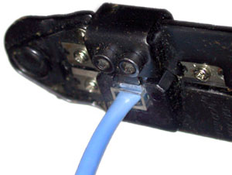

**STEP 8: Open the crimping tool and remove your newly-crimped Ethernet connector.**

**STEP 9: Repeat the crimping process on the other side of the cable if you're making a completely new cable.** If you're repairing one end, this won't apply to you, so move on.

**STEP 10:** Plug one end of the cable into the tan, two-port end of the cable tester, and the other end into the other part of the tester with the graphic display window

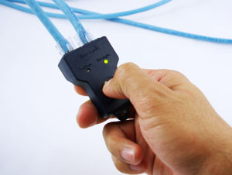

**STEP 11: Plug your Ethernet cable in.** Now that you've made an Ethernet cable all by yourself.

**Experiment No: 02**

**OBJECTIVE:** Steps for creating LAN cable cross cable

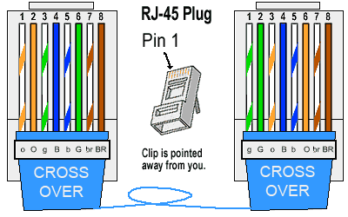**APPARATUS:** LAN cable cat6, RJ45 connectors, crimping tool, ethernet cable tester

**THEORY:** CROSSOVER CABLES - The purpose of a Crossover Ethernet cable is to directly connect one computer to another computer (or device) without going through a router, switch or hub.

**STEP 1: Strip your cable.** Use your cable strippers at about 1-2 inches from the end of the cable to remove the outer jacket.



**STEP 2:** **Untwist the twisted pair wires all the way back to the jacket.** This can be done just like a regular twist-tie on a loaf of bread, but with four of them of different colors.



**STEP 3:**

**Align the untwisted wires in the order necessary for your needs.** For this scenario, you'll be making a straight-through cable, which has both ends of the cable with the same alignment of wires, so it's easy enough to do. Since this is your first cable, we'll consult the cheat sheet to know what order we're aligning in!

**STEP 4: Cut the extra wire.** Once you've untwisted the wires, you'll have a superfluous amount of copper wiring left; we don't need this much, but it's good to have it in the previous step to help in aligning the colors properly. Use the wire-cutting scissors to cut these off.



**STEP 5: Push the remaining wires into the RJ45 head.** Be careful not to bend the wires while pushing them in or you run the risk of creating a bad cable. You also don't want too little or too much wire left in the head; there's no definite length necessary, but it's pretty obvious to tell if there's too much cable or not enough. A short length of the jacket should be up the RJ45 head; use this knowledge as a reference.



**STEP 6: Double-check that the wires are all the way up into the gold pins of the head and made it up in the proper order.** (Consult your cheat sheet if needed!)



**STEP 7: Push the head into the open space of the crimping tool and squeeze it closed, hard.** If you don't crimp the cable all the way, the head may come off.



**STEP 8: Open the crimping tool and remove your newly-crimped Ethernet connector.**

**STEP 9: Repeat the crimping process on the other side of the cable if you're making a completely new cable.** If you're repairing one end, this won't apply to you, so move on.

**STEP 10:** Plug one end of the cable into the tan, two-port end of the cable tester, and the other end into the other part of the tester with the graphic display window



**STEP 11: Plug your Ethernet cable in.** Now that you've made an Ethernet cable all by yourself.

**Experiment No: 03**

**Experiment Name:** Star Topology

**Objectives:**

1. Connection between pc and switch
2. Construction of Star topology

**Star topology** is a topology in which each network component is physically connected to a central node such as a router, hub or switch.

In a star topology, the central hub acts like a server and the connecting nodes act like clients. When the central node receives a packet from a connecting node, it can pass the packet on to other nodes in the network. A star topology is also known as a star network.

**Step 1:** We Have taken a switch and linked it to six end devices.

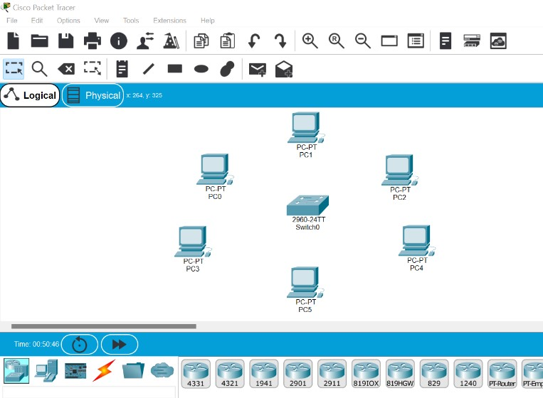

**Step 2:** Link Every Devices with the Switch

Hubs->switches: Cross Cable

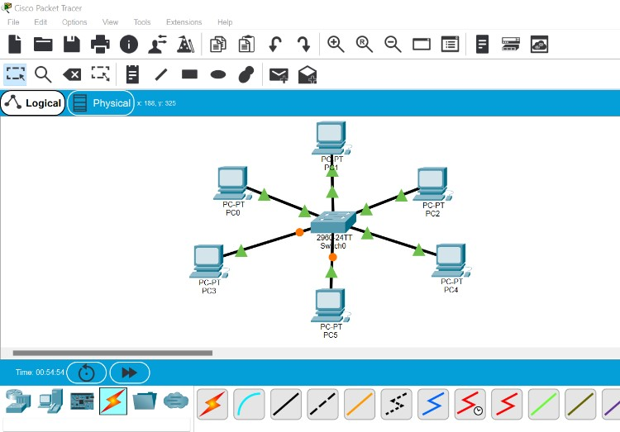

**Step 3:** Provide the IP address to each device.

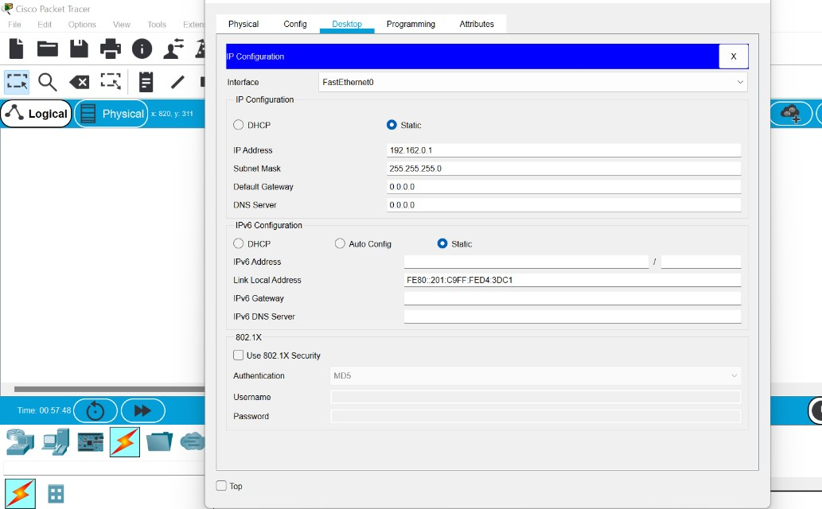

**S. No Device IPv4 Address Subnet Mask**

1. pc0 192.162.0.1 255.255.255.0
2. pc1 192.162.0.2 255.255.255.0
3. pc3 192.162.0.3 255.255.255.0
4. pc4 192.162.0.4 255.255.255.0
5. pc5 192.162.0.5 255.255.255.0
6. pc6 192.162.0.6 255.255.255.0

**Step 4:** Transfer message from one device to another

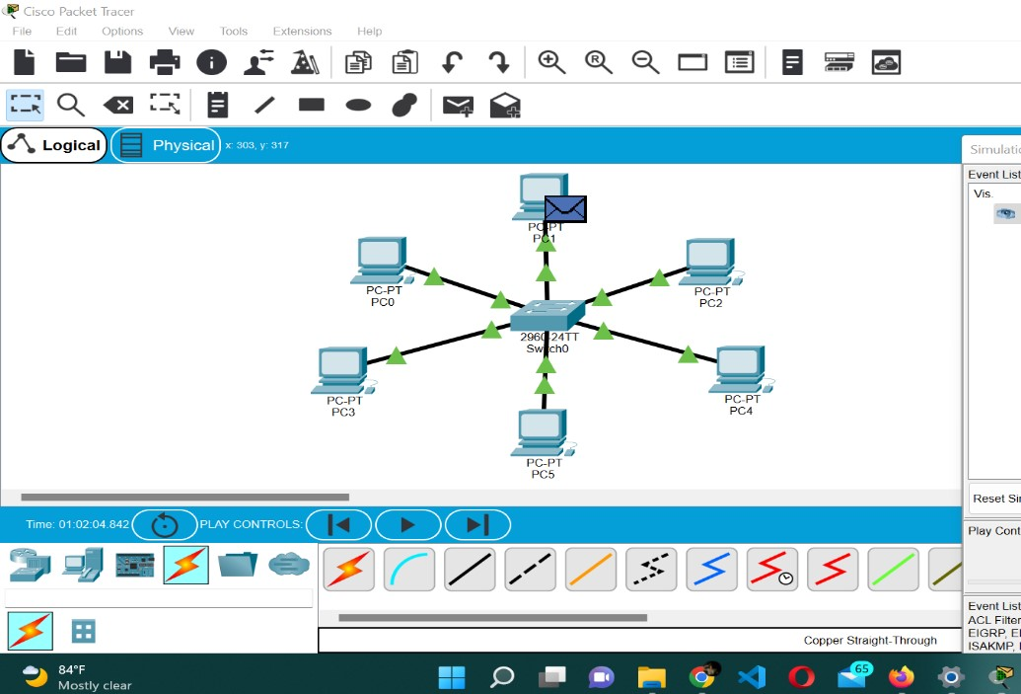

**Step 5:** Check Event List Table for Successful connection.

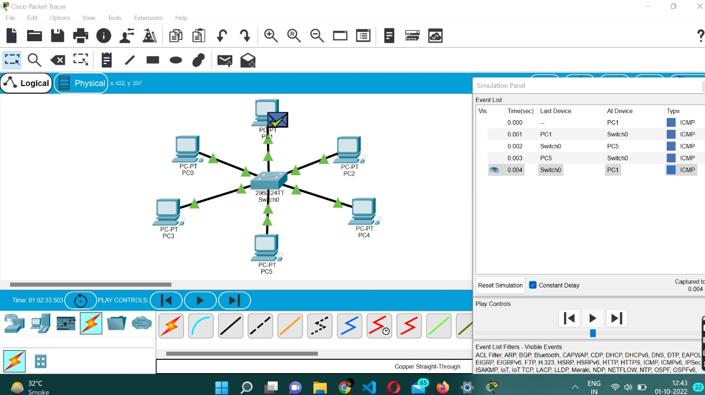

**Experiment No: 04**

**Experiment Name:** Bus topology

**Objective:**

* 1. Connection between pc and hub
  2. Connection between hub and hub
  3. Construction of bus topology

**Bus topology** is a specific kind of network topology in which all of the various devices in the network are connected to a single cable or line. In general, the term refers to how various devices are set up in a network.

**Implementation of bus topology**

**Step 1:** We have taken a multiple switch and linked it with end devices.

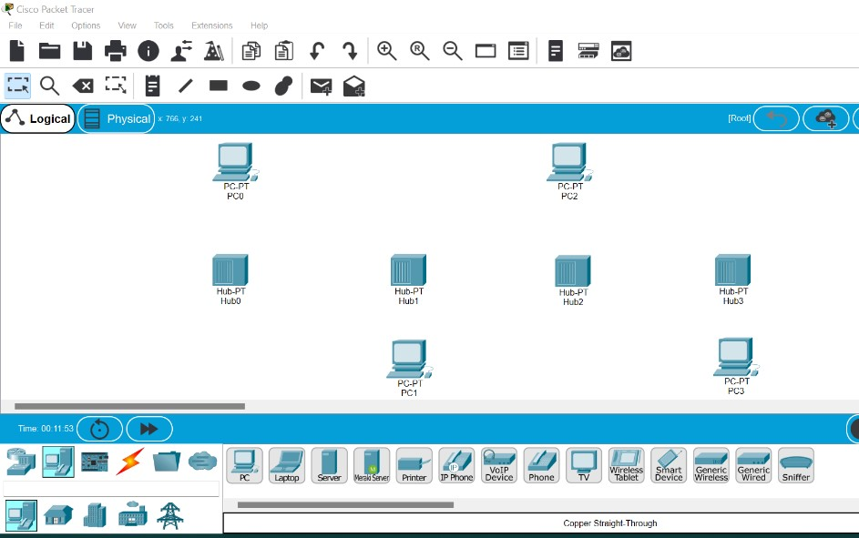

**Step 2:** Link hubs and switches as follows

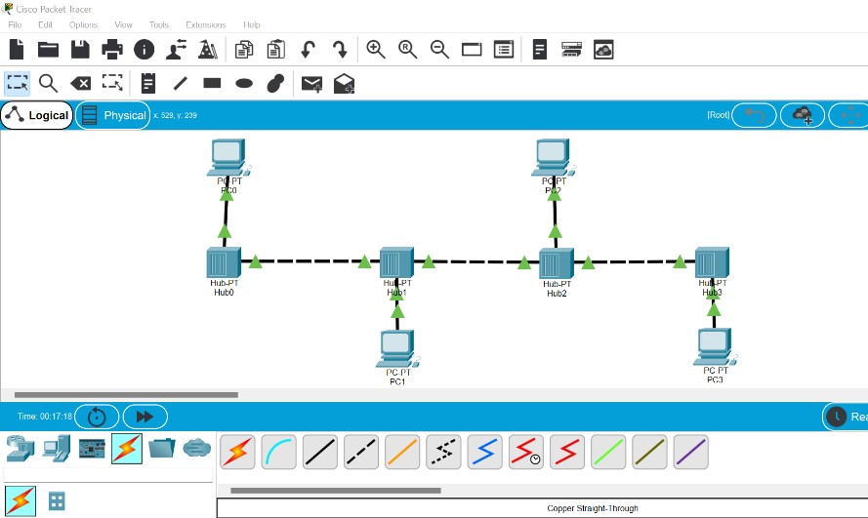

**Step 3:** Configure the PCs (hosts) with IPv4 address and Subnet Mask according to the IP addressing table given below

**S. No Device IPv4 Address Subnet Mask**

1. pc0 192.162.0.1 255.255.255.0
2. pc1 192.162.0.2 255.255.255.0
3. pc3 192.162.0.3 255.255.255.0
4. pc4 192.162.0.4 255.255.255.0

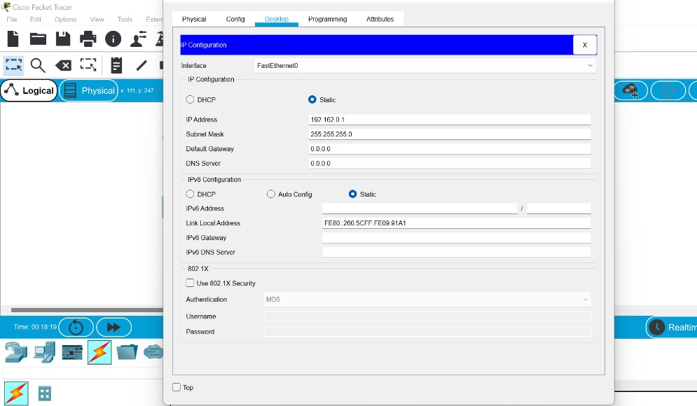

**Step 4:** Transfer message from one device to another

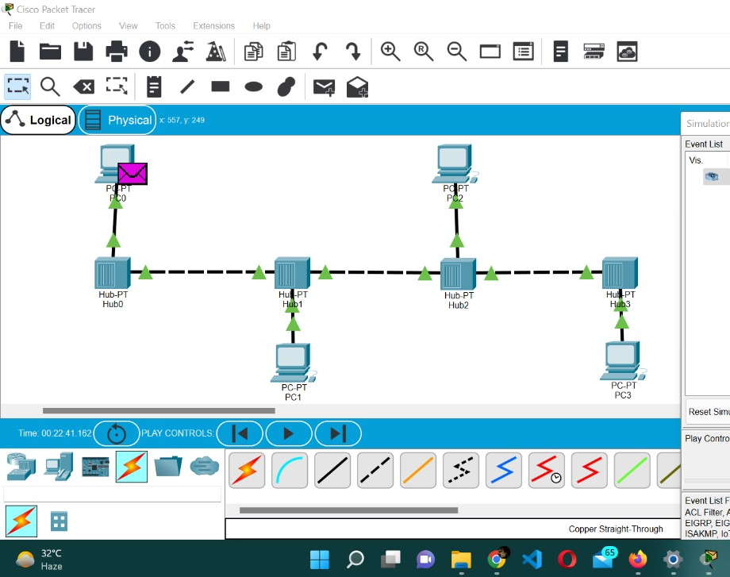

**Step 5:** Check event list table for to check for connection

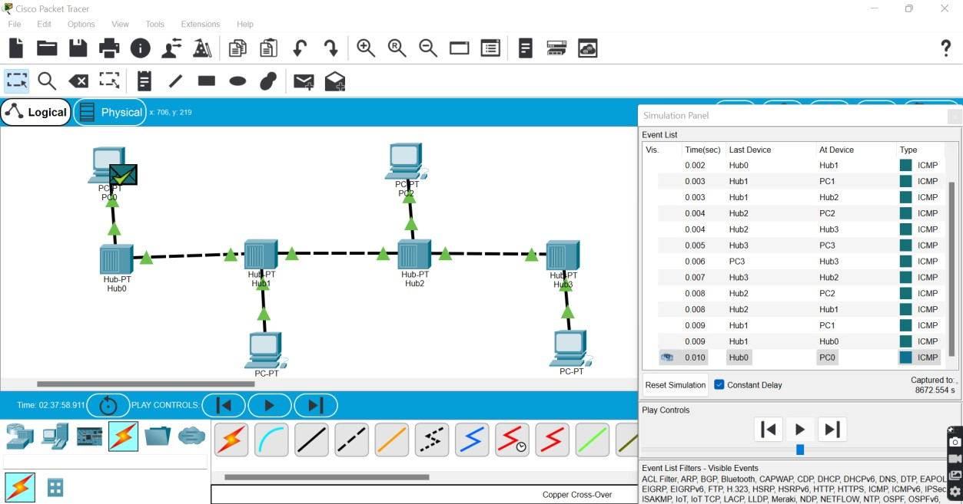

**Experiment No: 05**

**Experiment Name:** Mesh Topology

**Objectives:**

* 1. Connection between pc and switch
  2. Connection between Switch and Switch
  3. Construction of Mesh Topology

A **mesh topology** is a network setup where each computer and network device is interconnected with one another. This topology setup allows for most transmissions to be distributed even if one of the connections goes down. It is a topology commonly used for wireless networks. Below is a visual example of a simple computer setup on a network using a mesh topology.

**Implementation of Mesh topology**

**Step1:** We have taken a multiple switch and linked it with end devices.

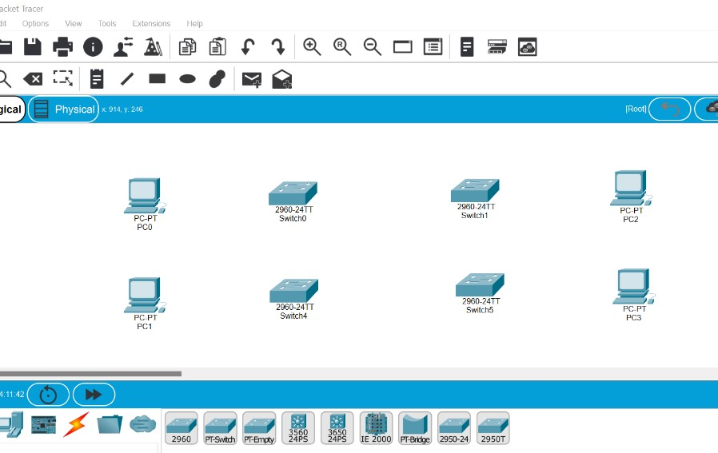

**Step 2:** Use Automatic Connecting Cable to connect the devices and create a network topology

Hubs->Hubs: Straight Cable

Hubs->switches: Cross Cable

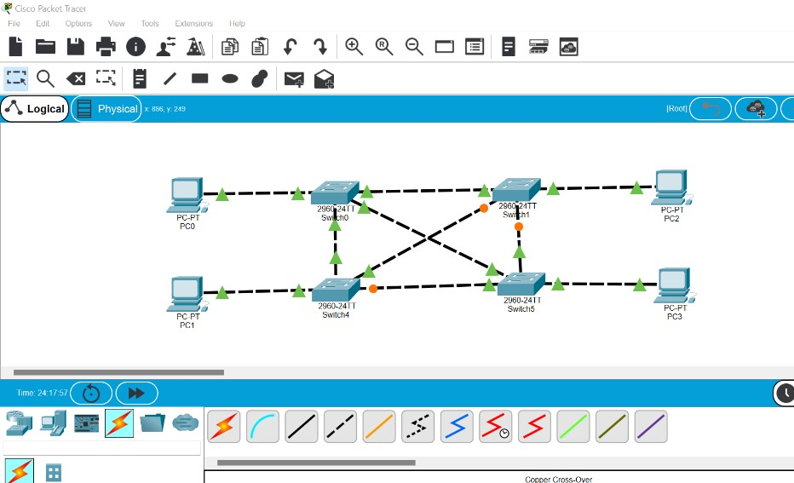

**Step 3:** Configure the PCs (hosts) with IPv4 address and Subnet Mask according to the IP addressing table given below

**S. No Device IPv4 Address Subnet Mask**

1. pc0 192.162.0.1 255.255.255.0
2. pc1 192.162.0.2 255.255.255.0
3. pc3 192.162.0.3 255.255.255.0
4. pc4 192.162.0.4 255.255.255.0

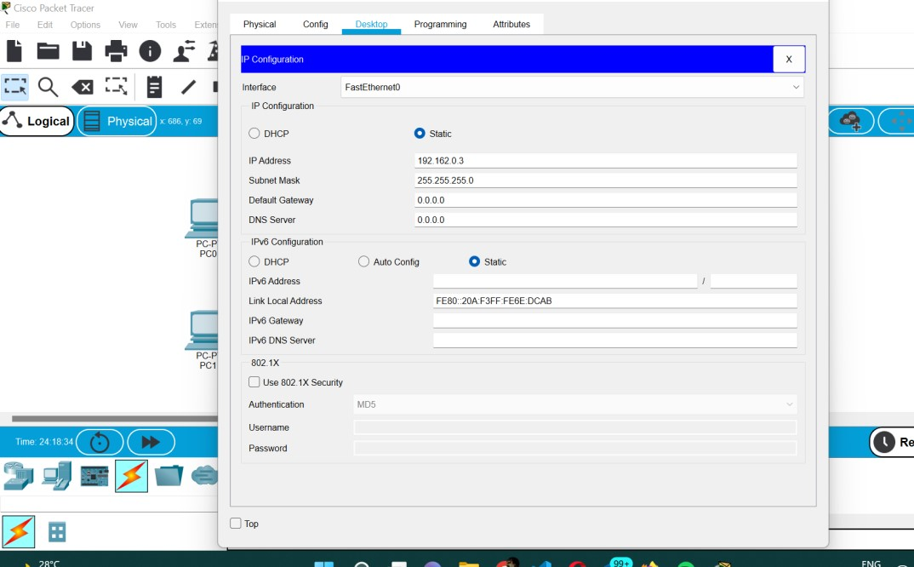

**Step 4:** Transfer message from one device to another and check the connection using table

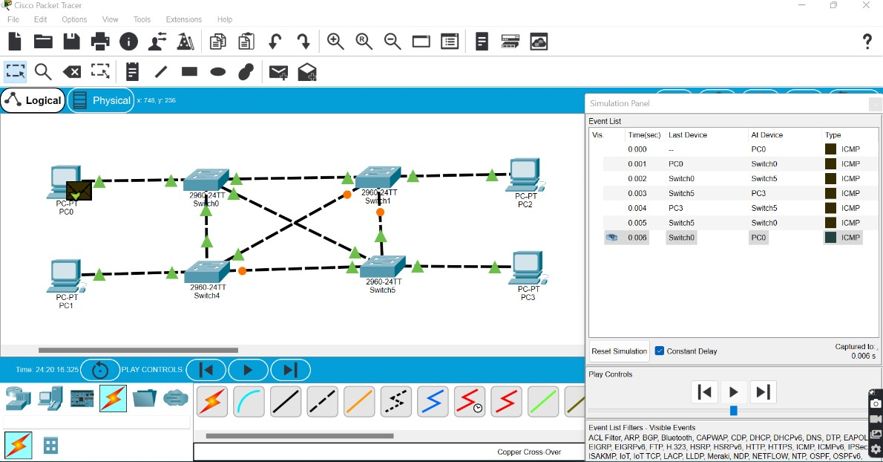

**Experiment No: 06**

**Experiment Name:** Tree Topology

**Objectives:**

* 1. Connection between pc and switch
  2. Connection between Switch and Switch
  3. Construction of Tree Topology

A **tree topology** is a special type of structure where many connected elements are arranged like the branches of a tree. For example, tree topologies are frequently used to organize the computers in a corporate network, or the information in a database**.**

**Implementation of Tree Topology**

**Step 1:** We have taken a multiple switch and linked it with end devices.

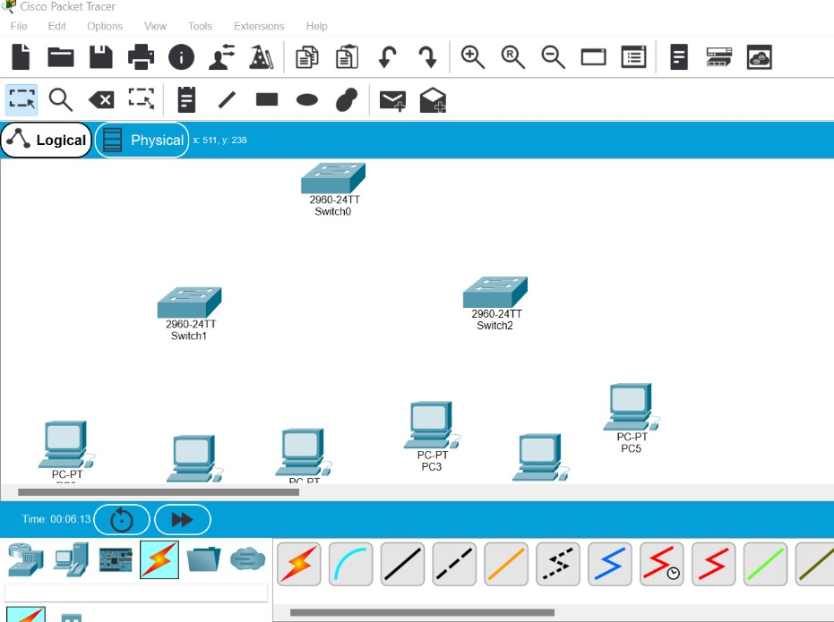

**Step 2:** Use Automatic Connecting Cable to connect the devices and create a network topology

Hubs->Hubs: Straight Cable

Hubs->switches: Cross Cable

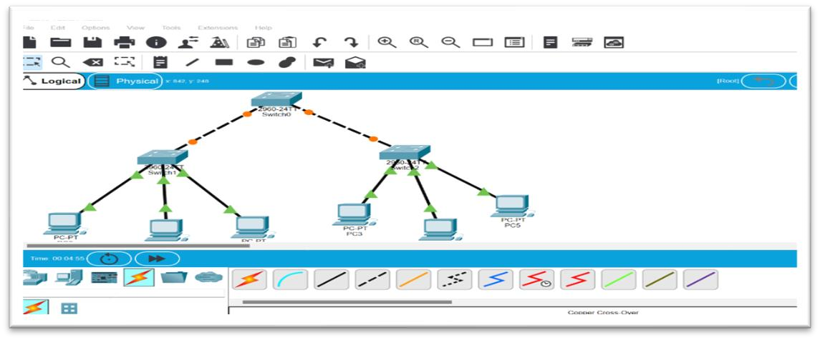

**Step 3:** Configure the PCs (hosts) with IPv4 address and Subnet Mask according to the IP addressing table given below

**S. No Device IPv4 Address Subnet Mask**

1. pc0 192.162.0.1 255.255.255.0
2. pc1 192.162.0.2 255.255.255.0
3. pc3 192.162.0.3 255.255.255.0
4. pc4 192.162.0.4 255.255.255.0
5. pc5 192.162.0.5 255.255.255.0
6. pc6 192.162.0.6 255.255.255.0

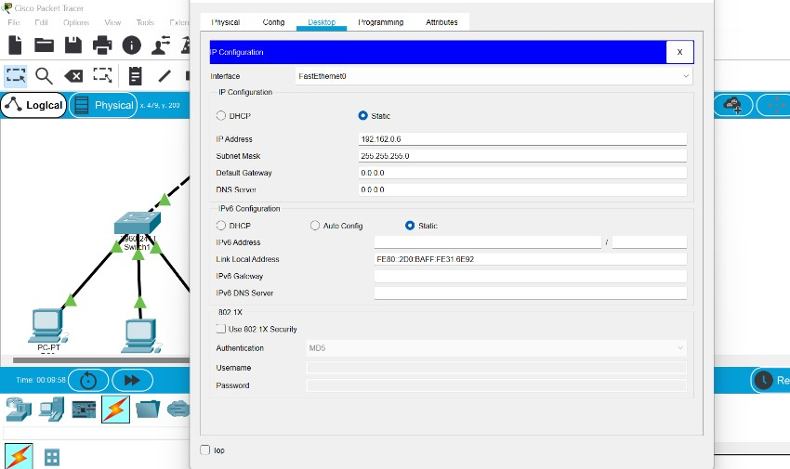

**Step 4:** Transfer message from one device to another

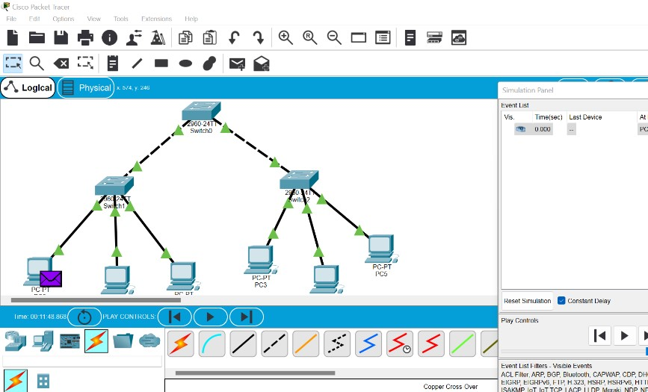

**Step 5:** Check event list table for to check connection

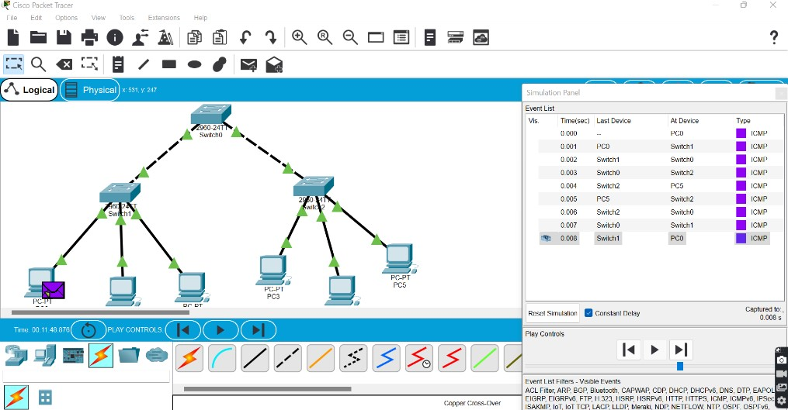

**Experiment No: 07**

**Experiment Name:** Ring Topology

**Objectives:**

1. Connection between pc and switch
2. Connection between Switch and Switch
3. Construction of Ring Topology

A **ring topology** is a network configuration where device connections create a circular data path. Each networked device is connected to two others, like points on a circle. Together, devices in a ring topology are referred to as a **ring network**.

**Implementation of Ring topology**

**Step1:** We have taken a multiple switch and linked it with end devices.

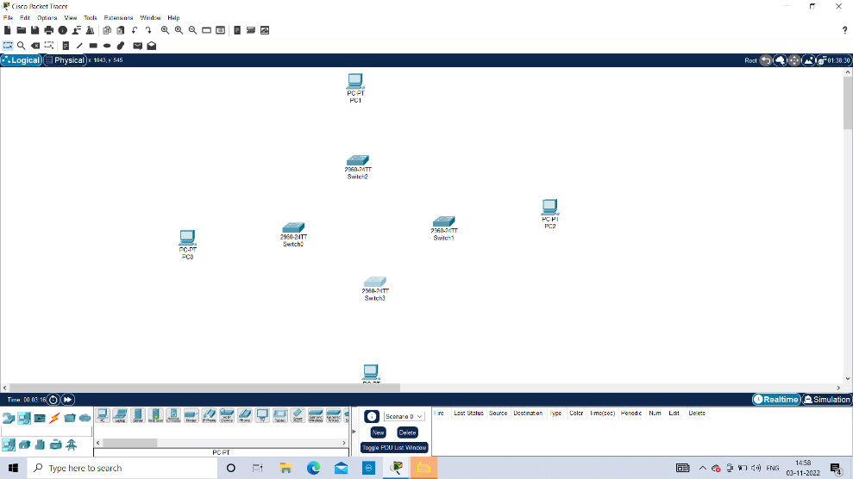

**Step 2:** Use Automatic Connecting Cable to connect the devices and create a network topology

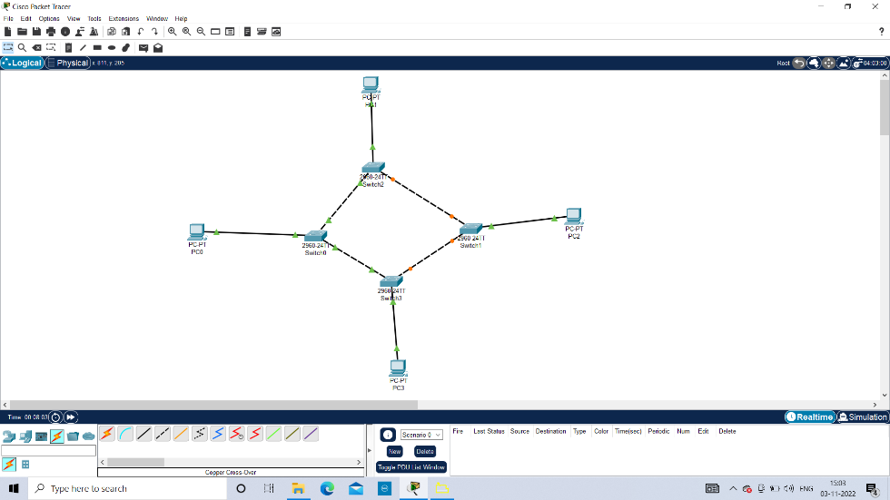

**Step 3:** Configure the PCs (hosts) with IPv4 address and Subnet Mask according to the IP addressing table given below

**S. No Device IPv4 Address Subnet Mask**

1. pc0 192.162.0.1 255.255.255.0

2. pc1 192.162.0.2 255.255.255.0

3. pc3 192.162.0.3 255.255.255.0

4. pc4 192.162.0.4 255.255.255.0

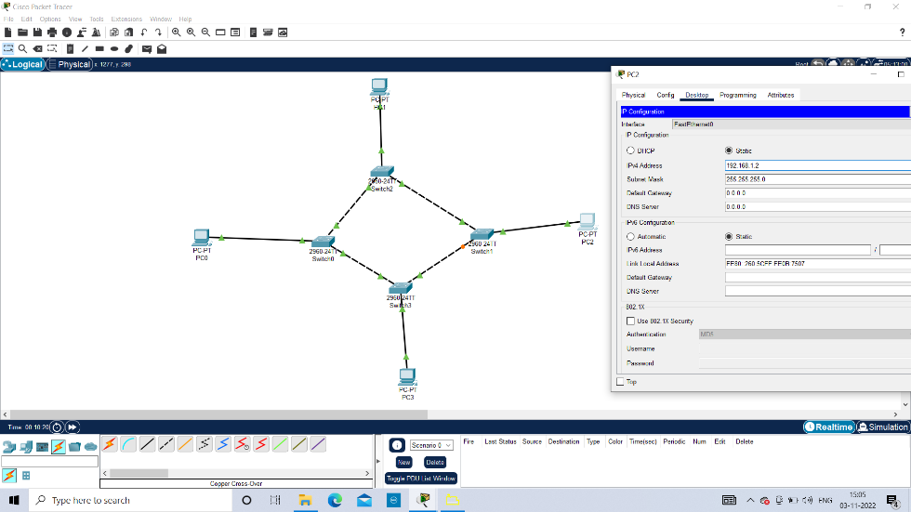

**Step 4:** Transfer message from one device to another and check the connection using table

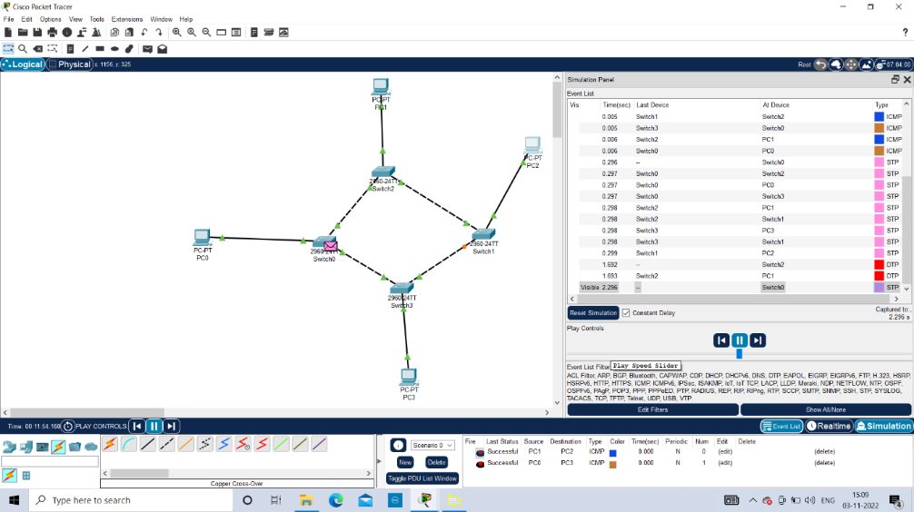

**Step 5:** Check event list table for to check for connection.

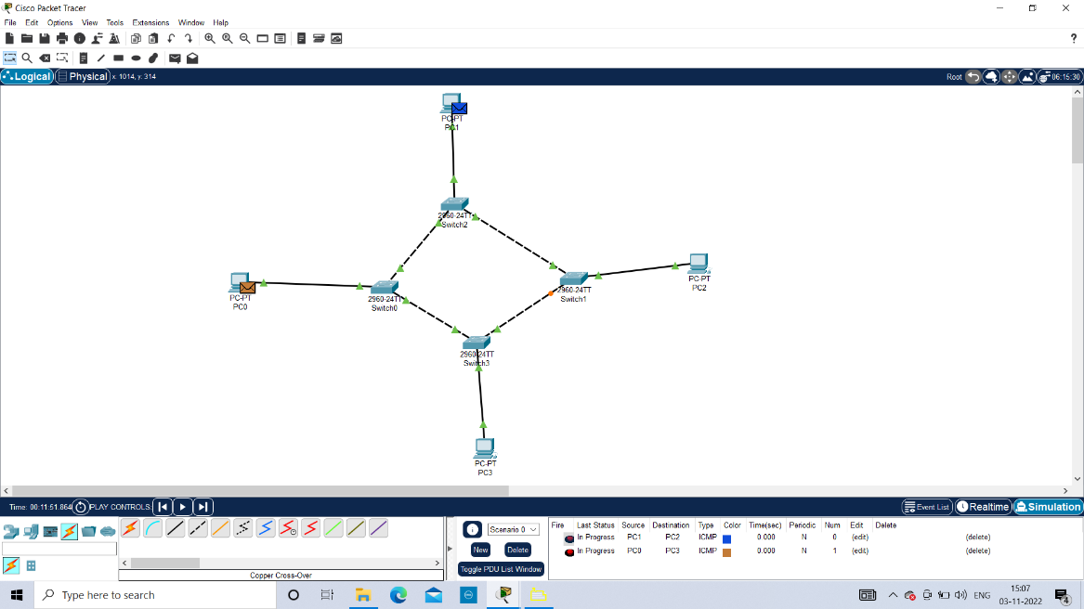

**Experiment No: 08**

**Experiment Name:**  Hybrid Topology

The arrangement of a network that comprises nodes and connecting lines via sender and receiver is referred to as network topology. The combination of two or more topologies in a computer network is called Hybrid Topology. These combined topologies can be a combination of bus topology, mesh topology, ring topology, star topology, and tree topology.

Now, complete the configurations, using following steps.

1. Connect each PC to the Switch using a Straight-Through Copper Cable Connection.
2. Double Click on any PC, in order to configure the network parameters.
3. Enter the IP address for each PC:
   * Go to Desktop Tab
   * Enter the IP Configurations Setting.
   * Enter the IP address, Subnet Mask and Default-Gateway.

**Step 1:** Open Cisco Packet tracer if you already have it installed.

# Figure 1

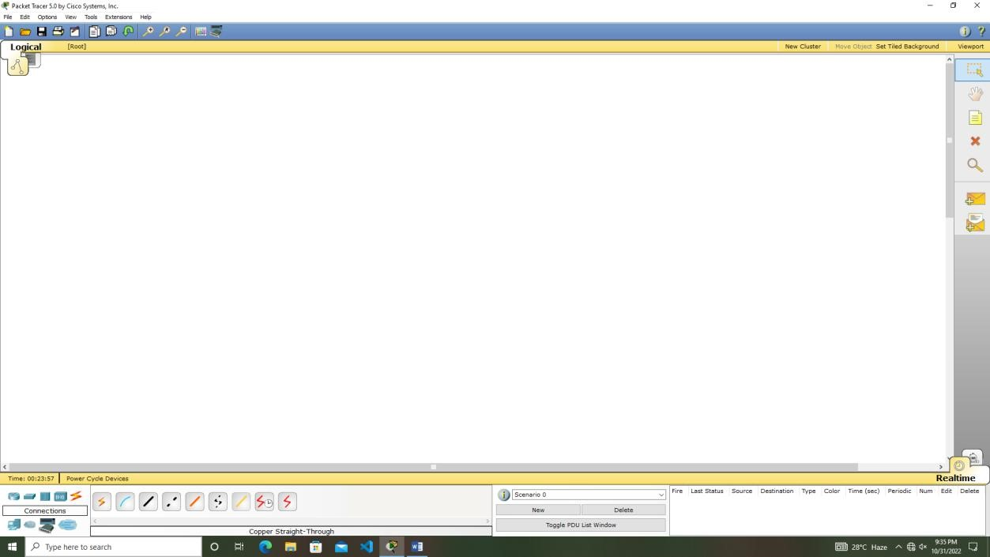

**Step 2:** On opening Cisco Packet Tracer select “Switches” from the bottom left icons menu (Figure 2), on clicking “Switches” you will notice the menu to its right changes, displaying various switches. From this middle menu click and drag required no. of switches (Figure 3) to the white screen (work area).

Figure 2

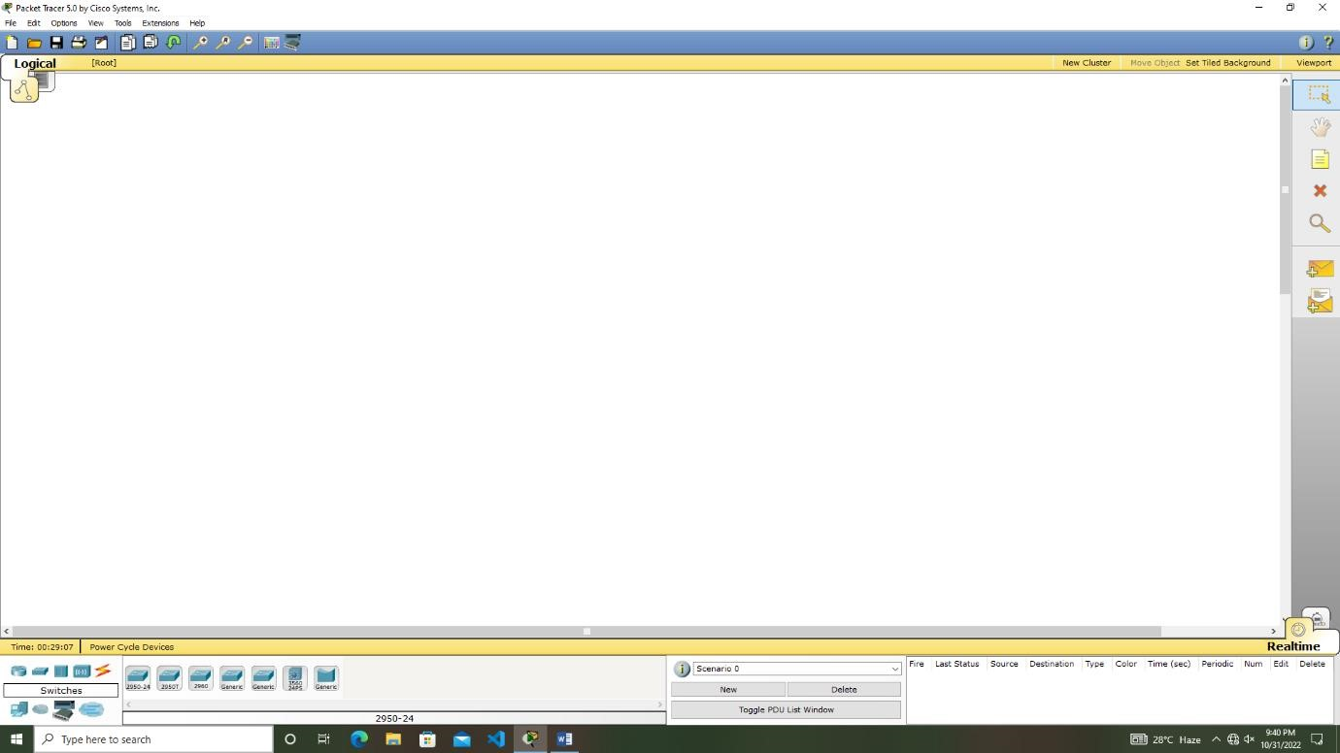

Figure 3

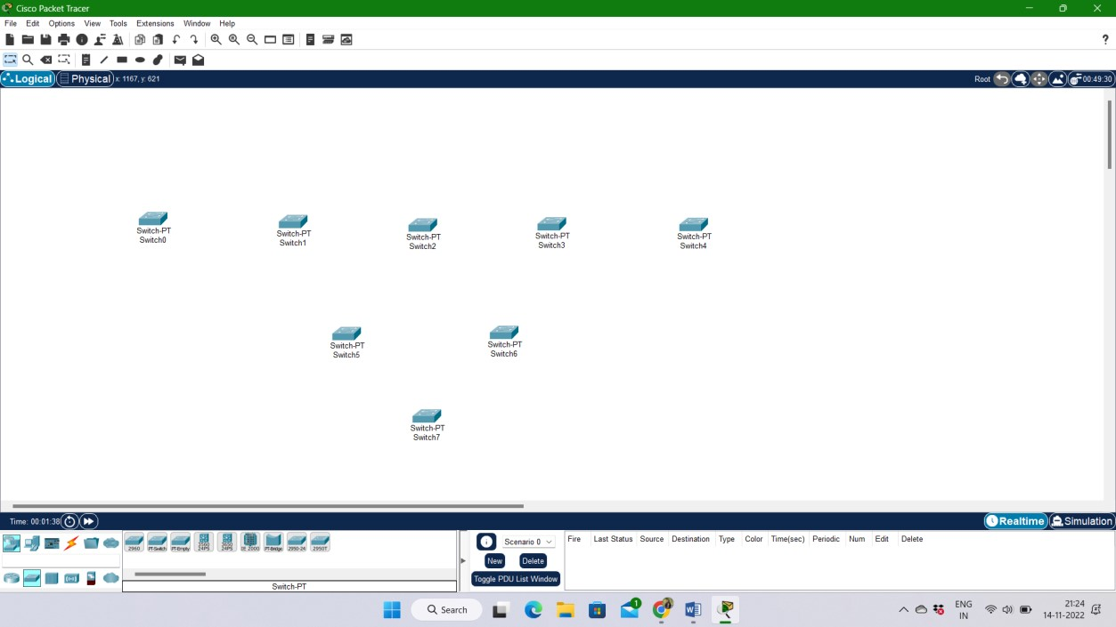

**Step 3:** Connect all switches using cross cable (Figure 4) from connection menu and establish the connection between them (Figure 5).

Figure 4

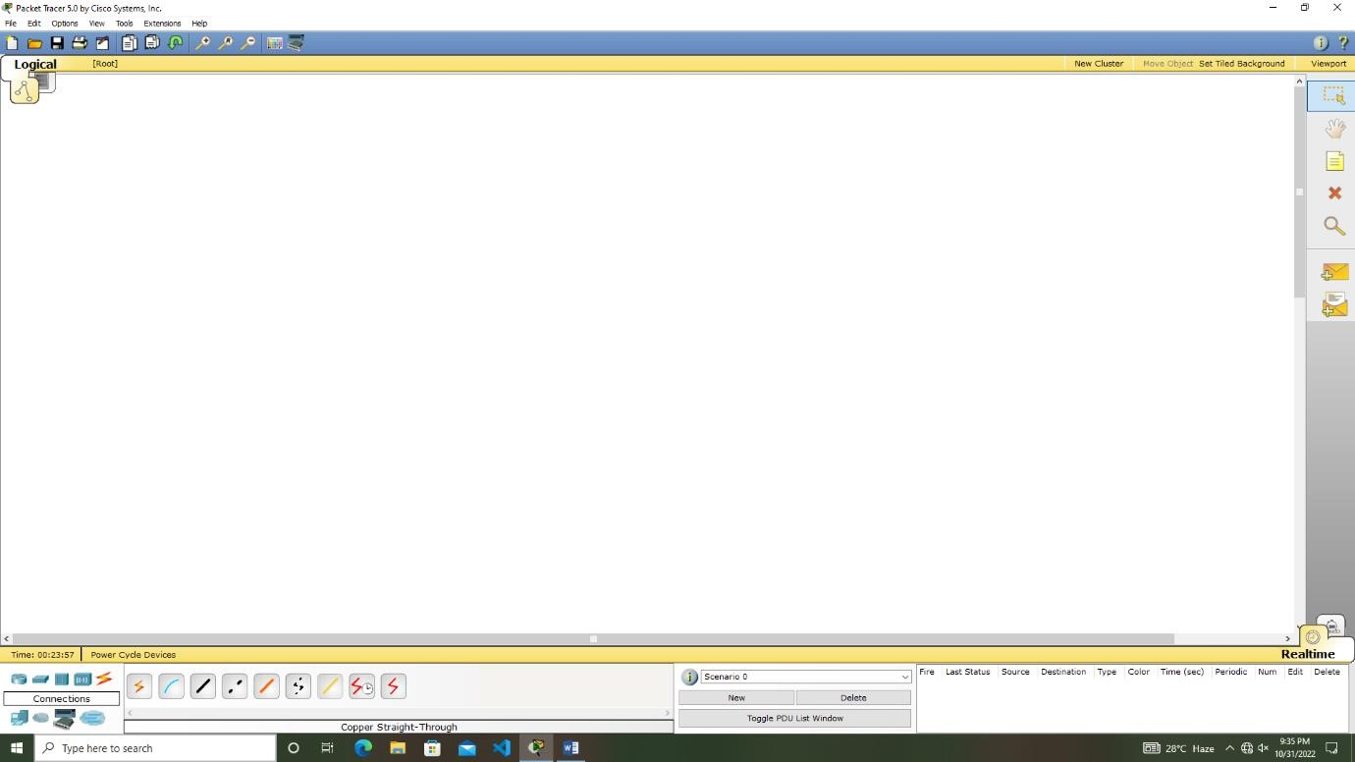

Figure 5

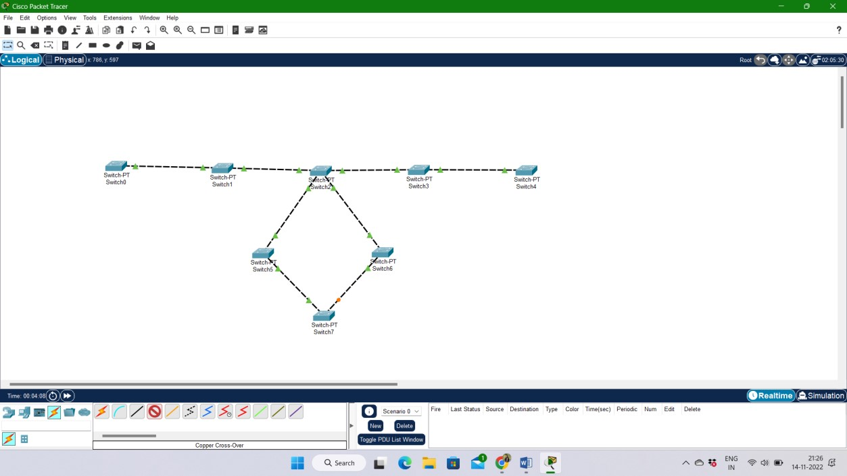

**Step 4:** On opening Cisco Packet Tracer select “End Devices” from the bottom left icons menu on clicking “End Devices” you will notice the menu to its right changes, displaying end devices like computers, phones and TV etc. From this middle menu click and drag required no. of computers (Figure 6) to the white screen (work area) and connect PCs with switches using straight cable (Figure 7).

Figure 6

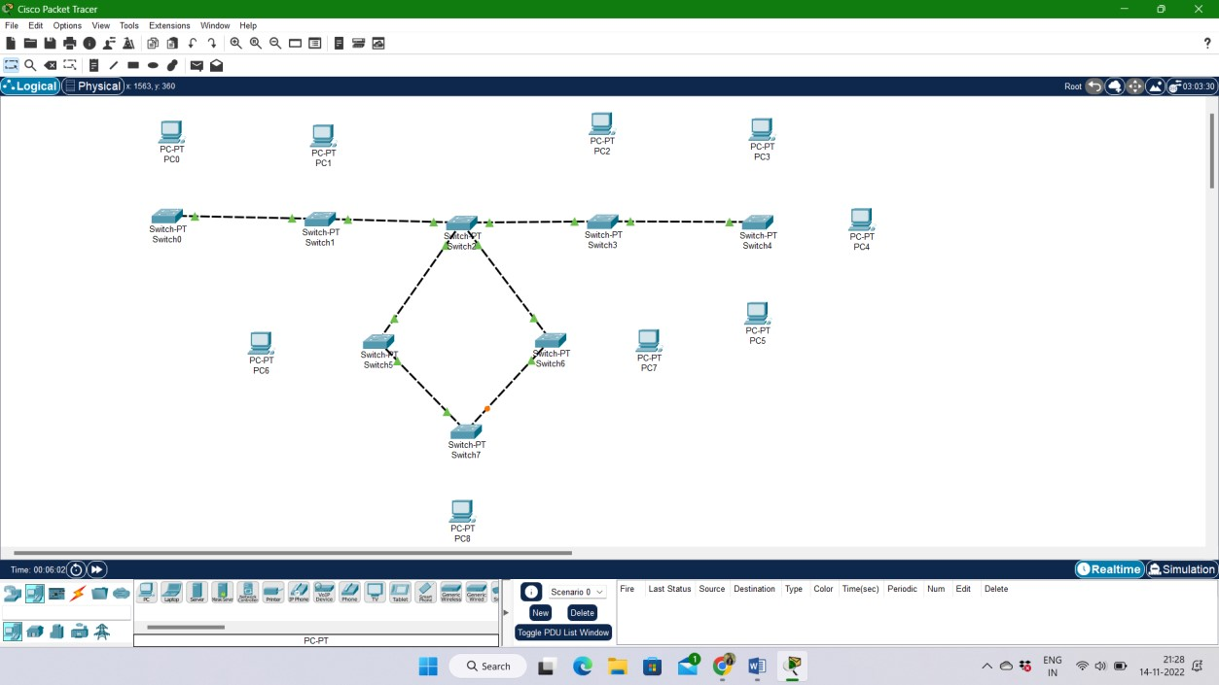

Figure 7

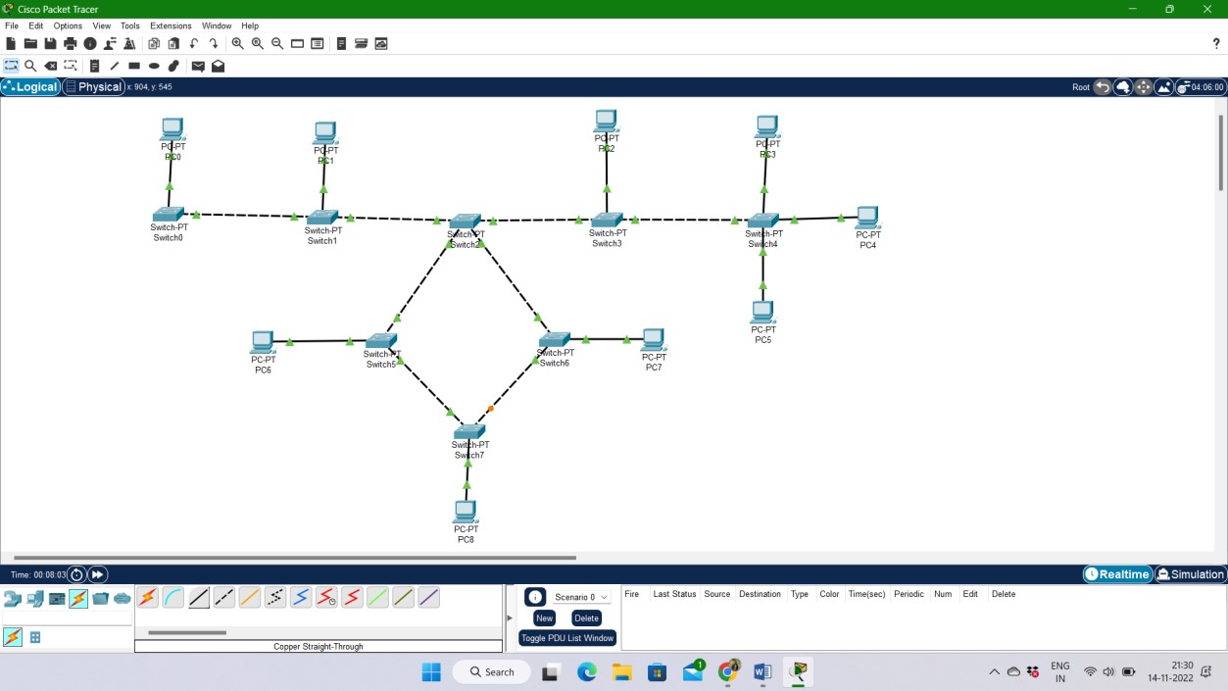

**Step 5:** Configure the PCs (hosts) with IPv4 address and Subnet Mask according to the IP addressing table given below

S. No Device IPv4 Address Subnet Mask

1. PC0 192.162.0.1 255.255.255.0
2. PC1 192.162.0.2 255.255.255.0
3. PC2 192.162.0.3 255.255.255.0
4. PC3 192.162.0.4 255.255.255.0
5. PC4 192.162.0.5 255.255.255.0
6. PC5 192.162.0.6 255.255.255.0
7. PC6 192.162.0.7 255.255.255.0
8. PC7 192.162.0.8 255.255.255.0
9. PC8 192.162.0.9 255.255.255.0

# Figure 8

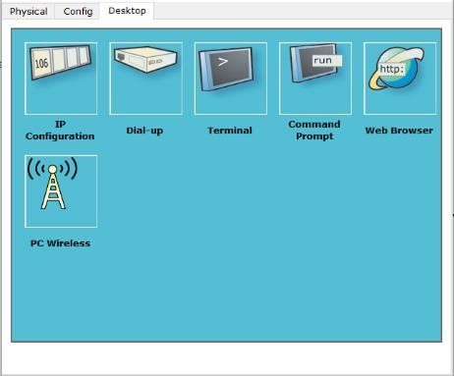

# Figure 9

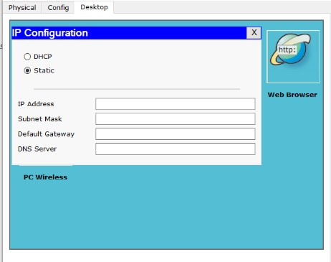

# Figure 10

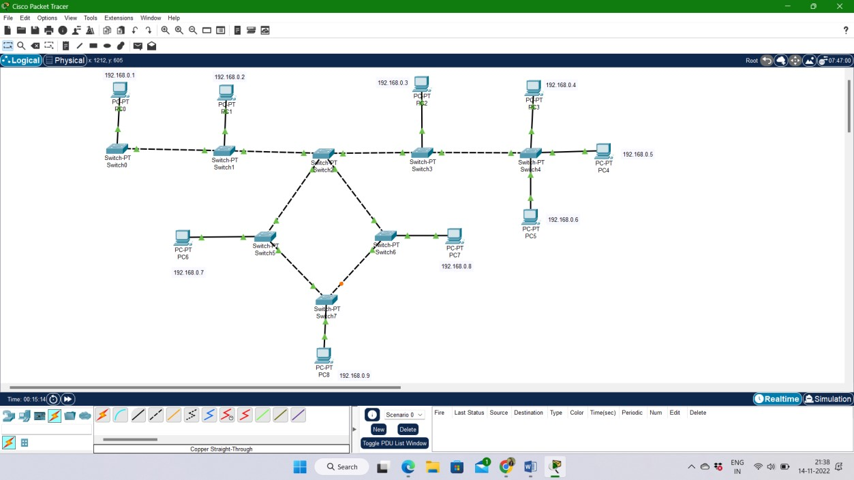

**Step 6:** For validating if our computer can communicate through switch we use ping, if pinging the other computer results in no packet loss then we are good and having a working network. Now click on UpaaePC0 and select command prompt. As we know that UpaaePC0 has the IP address of 192.168.0.1 so we will enter “ping 192.168.0.1” at the command prompt and wait for the result.

Figure 11

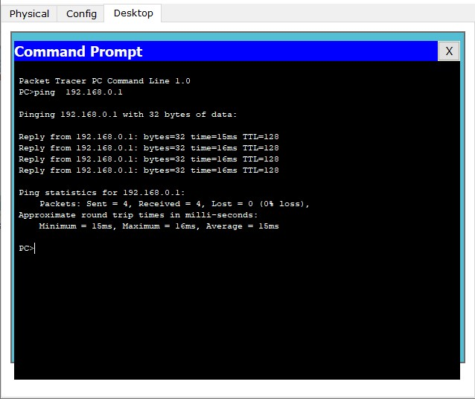

If you have followed each step correctly you will get result like this otherwise repeat these steps until you have correct configuration.

**Step 7:** Check event list table for to check for connection.

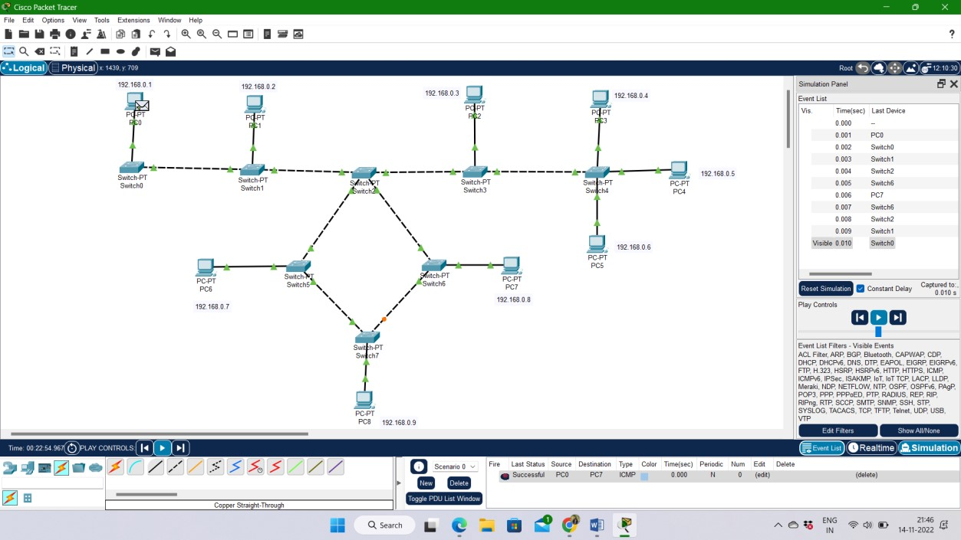

**Experiment No: 09**

**Experiment Name:** WRITE A PROGRAM OF BIT STUFFING IN C.

#include<stdio.h>

#include<string.h>

int main()

{

    int a[20],b[30],i,j,k,count,n;

    printf("Enter frame size (Example: 8):");

    scanf("%d",&n);

    printf("Enter the frame in the form of 0 and 1 :");

    for(i=0; i<n; i++)

        scanf("%d",&a[i]);

    i=0;

    count=1;

    j=0;

    while(i<n)

    {

        if(a[i]==1)

        {

            b[j]=a[i];

            for(k=i+1; a[k]==1 && k<n && count<5; k++)

            {

                j++;

                b[j]=a[k];

                count++;

                if(count==5)

                {

                    j++;

                    b[j]=0;

                }

                i=k;

            }

        }

        else

        {

            b[j]=a[i];

        }

        i++;

        j++;

    }

    printf("After Bit Stuffing :");

    for(i=0; i<j; i++)

        printf("%d",b[i]);

    return 0;

}

**OUTPUT**

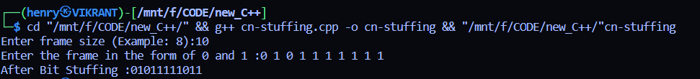

**Experiment No: 10**

**Experiment Name:** WRITE A PROGRAM OF CHARACTER STUFFING IN C.

#include<stdio.h>

#include<string.h>

int main()

{

        char a[30], fs[50] = " ", t[3], sd, ed, x[3], s[3], d[3], y[3];

        int i, j, p = 0, q = 0;

        printf("Enter characters to be stuffed:");

        scanf("%s", a);

        printf("\nEnter a character that represents starting delimiter:");

        scanf(" %c", &sd);

        printf("\nEnter a character that represents ending delimiter:");

        scanf(" %c", &ed);

        x[0] = s[0] = s[1] = sd;

        x[1] = s[2] = '\0';

        y[0] = d[0] = d[1] = ed;

        d[2] = y[1] = '\0';

        strcat(fs, x);

        for(i = 0; i < strlen(a); i++)

        {

            t[0] = a[i];

            t[1] = '\0';

            if(t[0] == sd)

                strcat(fs, s);

            else if(t[0] == ed)

                strcat(fs, d);

            else

                strcat(fs, t);

        }

        strcat(fs, y);

        printf("\n After stuffing:%s", fs);

}

**OUTPUT**

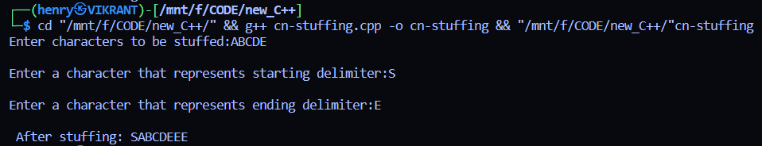

**Experiment No: 11**

**Experiment Name:** EXECUTE THE FOLLOWING NETWORK ORIENTED COMMANDS AND OBSERVE THEIR OUTPUT.

* **ping**
* **tracert**
* **hostname**
* **ipconfig**
* **arp**
* **netstat**

**1. ping:** The ping command operates by sending Internet Control Message Protocol (ICMP) Echo Request messages to the destination computer and waiting for a response. The two major pieces of information that the ping command provides are how many of those responses are returned and how long it takes for them to return.

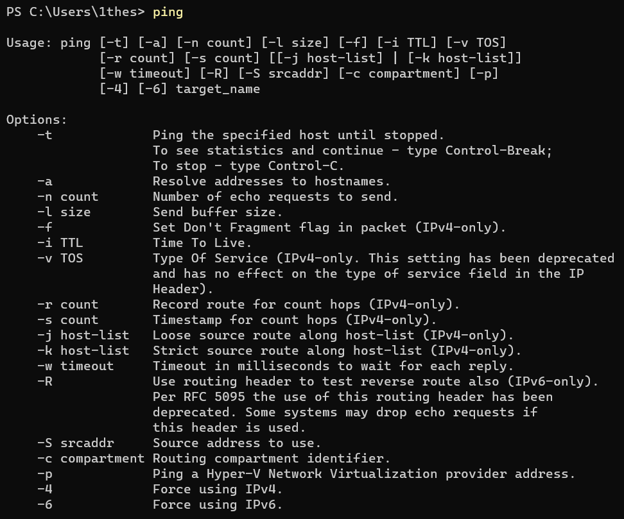

**2.tracert:** The Windows Tracert tool determines the route to a destination by sending ICMP packets to the destination. In these packets, Tracert uses varying IP Time-To-Live (TTL) values.

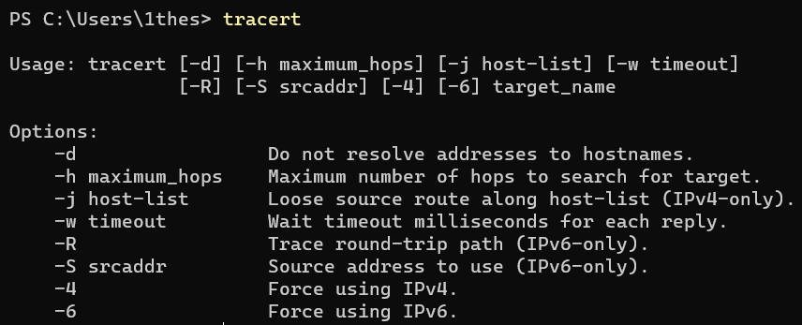

**3.hostname:** A hostname is a name which is given to a computer and it attached to the network. Its main purpose is to uniquely identify over a network.



**4.ipconfig:** A command line utility that is used to display manage the IP address assigned to the machine.

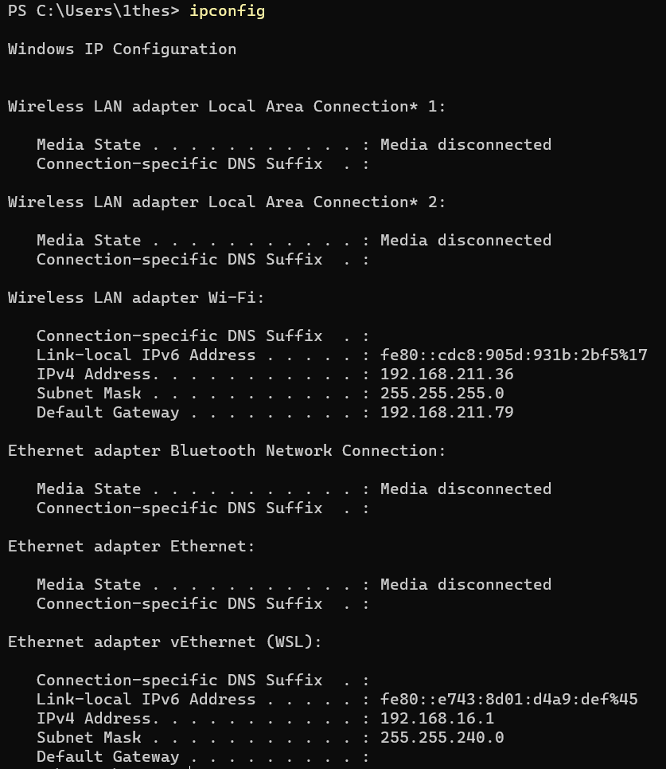

**5.arp:** The arp command displays and modifies the Internet-toadapter address translation tables used by the Address in Networks and communication management. The arp command displays the current ARP entry for the host specified by the HostName variable.

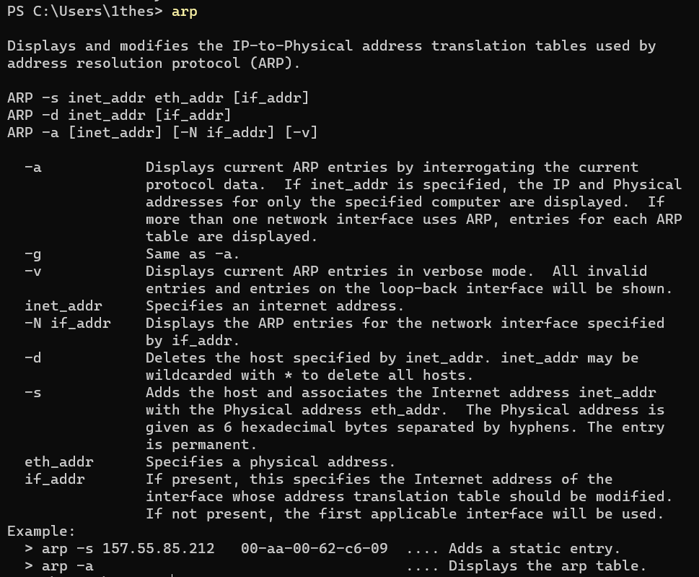

**6.netstat:** The netstat command displays the contents of various network-related data structures for active connections. This netstat function shows the state of all configured interfaces. This function of the netstat command clears all the statistic counters for the netstat -i command to zero.

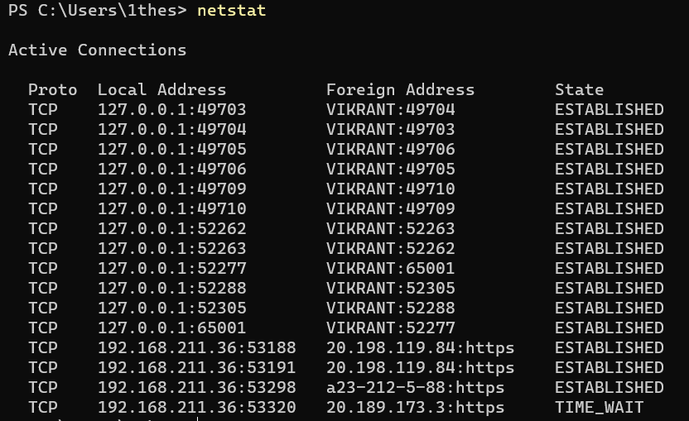

**Experiment No: 12**

**OBJECTIVE:** Steps to connect Two Computers Using straight/cross LAN Cable in Windows.

With a crossover cable in hand, the steps are pretty straightforward.

**Step 1:** Go to “Control Panel -> Network and Internet -> Network and Sharing Center -> Change Adapter Settings.”

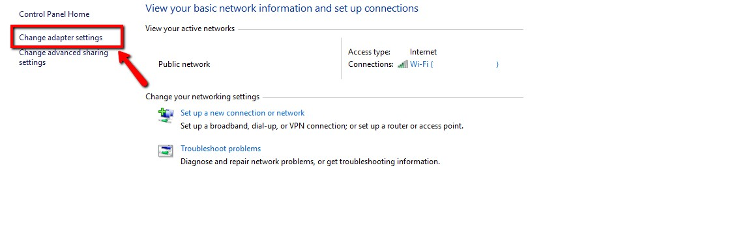

**Step 2:** Click on “Change Adapter Settings.” This will reveal different connections. Select the appropriate connection for your LAN. Usually, but not necessarily, the connection will be called Ethernet and have the description network cable unplugged.

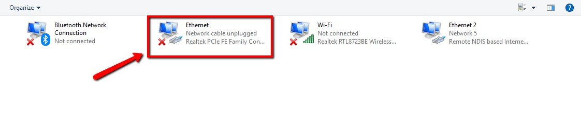

Right-click on the connection and select “Properties.” The local area’s connection properties window will appear.

**Step 3:** Under the network tab select “Internet protocol version 4 (TCP/IPv4),” then click on “Properties.”

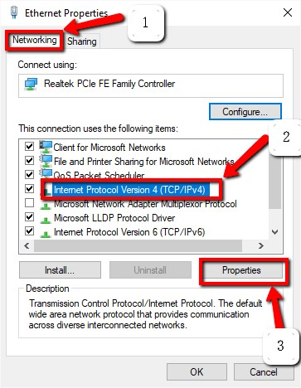

In the Properties windows set the IP address and subnet masks of the first computer to:

* + IP – 192.168.0.1
  + Subnet Mask – 225.225.225.0

Repeat all the above steps for the second computer, and set the IP address and subnet Mask as follows:

* + IP – 192.168.0.2
  + Subnet Mask – 225.225.225.0

**Note**: it is important to ensure that the last values of the IP address for both computers are different.

**Step 4:** The next step is to connect the crossover cable to the network ports of the two computers.

Both ends of the network cable look the same, so it doesn’t matter which end you use first. The network ports look something like the image below. (Do note that most modern ~~computers~~ laptops don’t come with a LAN port.)

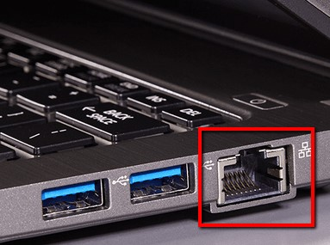

**Step 5:** Right-click on “This PC,” and choose “Properties.” Click on “Change settings -> Change.” This reveals the window with the name of the work group. The value for the workgroup name should be the same for both PCs. By default, the workgroup name will be WORKGROUP, but you can change it to any name you like.

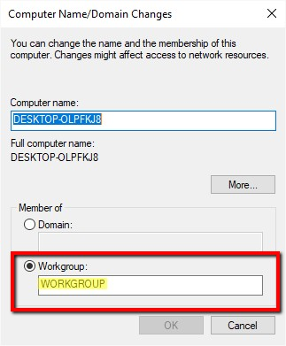

**Step 6:** Right-click on the drive you want to share. Scroll to the “Give access to” option and click “Advanced Sharing.” Under the sharing tab, click the “Advanced Sharing” button.

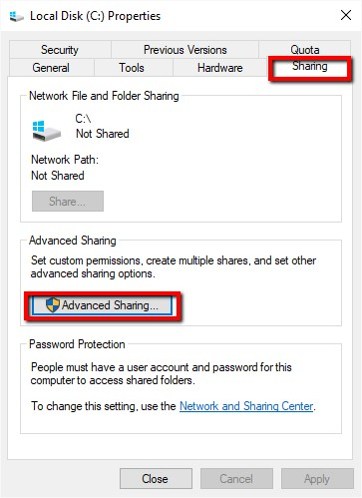

This reveals the advanced sharing window. Check the “Share this folder” checkbox, and click “Apply -> OK.”

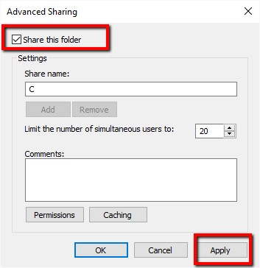

At this stage, you will have successfully connected the two Windows computers to share your drives between them.

**Transferring Files**

Specific folders or files can now be transferred. To share specific folders or files from

Computer A (ADMIN-HP) with Computer B, simply right-click the desired folder or file in

Computer A, scroll to the “Give access to” option and click “Specific People.”